Apply the Law of Cosines in order to solve the triangles for all missing side lengths and angle measures.
Round answers to the nearest hundredth.
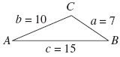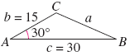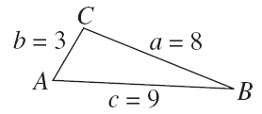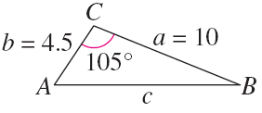

A baseball player in center field is playing approximately 330 feet
from the television camera that is behind home plate. A batter hits a
fly ball that goes to the wall 420 feet from the camera. The camera
turns 8° to follow the play. Approximately how far does the center
fielder have to run to make the catch?

